**TITLE OF PROJECT REPORT**

A MINI PROJECT REPORT

Submitted by

Group No: G21

Keshav Bhalla, 2301991869

Kavita Sharma,2301991868

Kashish Sharma,2301991867

in partial fulfilment for the award of the

 degree of

**BACHELEOR OF ENGINEERING**

**in**

**COMPUTER SCIENCE & ENGINEERING**



CHITKARA UNIVERSITY

CHANDIGARH-PATIALA NATIONAL HIGHWAY

RAJPURA (PATIALA) PUNJAB-140401 (INDIA)

**October 2023**

**Abstract**

The Title Of the project is “Personal Finance manager”. The purpose of the project is to help our website user to reach their future financial goal whether it is to buy a home in future or do a bigger investment in different plots or to resolve their financial status problems. Our user can have a talk with the most professional finance managers on our website who are ready to help them eagerly. There are two main problems solved by our website . First , is to help our website user to reach their future financial goal .  For example a person thinks of buying a house in future and his current financial situation is not as good to meet the requirements for this goal . So he can register with us so that we can help him and many more others like him to rectify problems that are stopping them to reach their financial goal. But why choose our website if a personal finance manger can help them in his/her office? Answer is simple: ‘Paperload’ . Even though a person can reach out to a finance manager for different solutions to their problems but their might a lot of paperwork involved and lot of travelling might be involved in this task . So rather than this , why not spend valuable time to your manage your money by sitting just at home , avoiding paperwork and using a user friendly graphics website which is easy to use. Few important features in our website are Graphs, Notifications, Animations and Calculators. We have used HTML and CSS(all three: Internal CSS, External CSS, Inline CSS) to make our project. We have used Visual Studio Code to write our codes. A unique Feature we have added in our website is that we have provided our user not only with expense calculator but also with other different types of calculator . For example Loan Calculator, Saving Calculator , Budget Calculator, ROI Calculator .Making the website was interesting and fun and we learnt many topics for example Introduction to HTML, More on HTML, Forms, Introduction to CSS, Styling with CSS, Flex , More on styling, Responsive Design.

Made by:                                                                                          Faculty Coordinator:

Keshav Bhalla (2310991869)                                                          DR. Bhisham Sharma

Kavita Sharma (2310991868)

Kashish Sharma (2310991867)

|  |  |  |
| --- | --- | --- |
| **Sr.no** | **Section** | **Page no** |
| 1 | Introduction | **2** |
| 2 | Problem Statement | **3** |
| 3 | Technical Details | **4** |
| 4 | Key Features | **5** |
| 5 | Project Highlights | **6** |
| 6 | Bonus Feature | **7** |
| 7 | Conclusion | **8** |
| 8 | Reference/Links used | **9** |

**TABLE OF CONTENTS**

**INTRODUCTION**

**“***LIVE YOUR FINANCIAL LIFE STRESS FREE***”**

The title of the project is --- “Personal Finance Manager” .

The team members are --- Keshav Bhalla (2301991869)

                                                Kavita Sharma (2301991868)

                                               Kashish Sharma (2301991867)

* The purpose of the project is to help our website user to reach their future financial goal whether it is to buy a home in future or do a bigger investment in different plots or to resolve their financial status problems.
* Our user can have a talk with the most professional finance managers on our website who are ready to help them eagerly.

**PROBLEM STATEMENT**

There are two main problems solved by our website:

* For example a person thinks of buying a house in future and his current financial situation is not as good to meet the requirements for this goal. So he can register with us so that we can help him and many more others like him to rectify problems that are stopping them to reach their financial goals
* But why choose a problem finance manager can help them in his/her office? Answer is simple: ‘Paperload’. Even though a person can reach out to a finance manager for different solutions to their problems but their might a lot of paperwork involved and lot of travelling might be involved in this task. So rather than this, why not spend valuable time to your manage your money by sitting just at home, avoiding paperwork and using a user friendly graphics website which is easy to use.

**TECHNICAL DETAILS**

As we have got this project under the subject ***‘FRONT END ENGINEERING’*** we have mainly used HTML and CSS codes.

Mainly used tags are:-

1. Title tag
2. Division tag
3. Anchor tag
4. Hyper reference tag
5. Image tag
6. Video tag
7. Font tag
8. Hr tag
9. Marquee tag
10. Heading tag
11. Footer tag
12. Table tag
13. External CSS
14. Internal CSS
15. Inline CSS



**KEY FEATURES**

The main key feature of our website is that we provide the users graphs . it creates a interactive charts, graph, and other visualizations, finance teams can quickly and easily communicate complex financial date to stakeholders.

We provide 3 types of graphs:

1. Income sources
2. Expenses by sub categories
3. Monthly Income

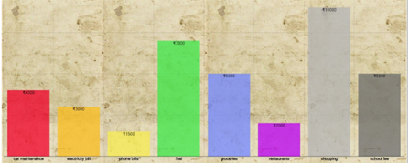

* Another key feature is that notifications will be provided our website to our user so that they remain alerted not only to their spendings and savings but also get aware time-to-time about shares they are currently investing in.
* Some times people get bored discussing about finance and checking their finance websites . So to resolve this issue we have used different animation, video, and in future we would be trying to add features like providing our users with interacting sessions on finance with renowed experts. This will help them to develop their knowledge in finance field.

**PROJECT HIGHLIGHTS**

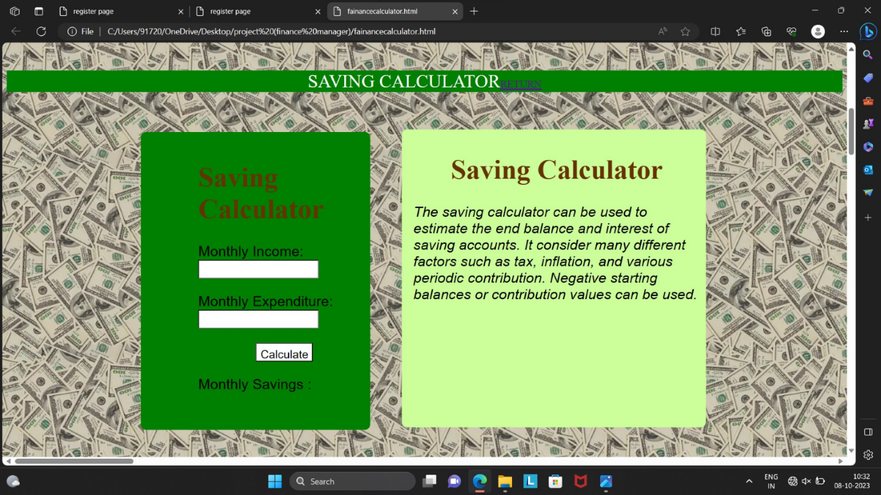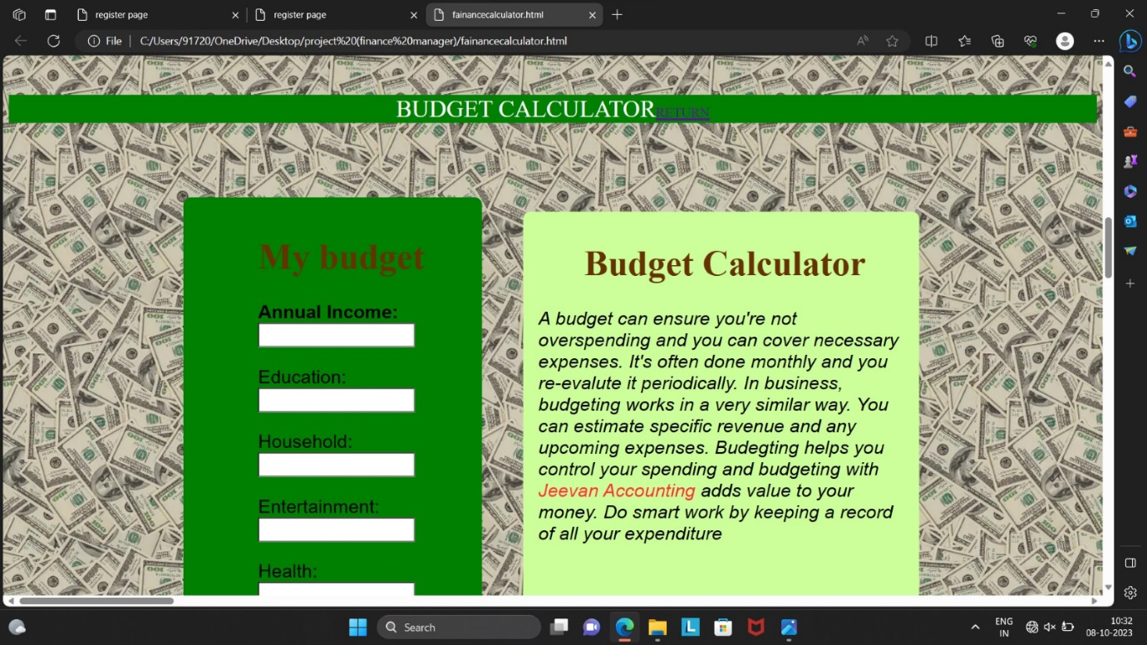

**BONUS FEATURES**

A unique Feature we have added in our website is that we have provide our user not only with expenses calculator but also with other different types of calculator . For example

* Loan calculator
* Saving calculator
* Budget calculator
* Roi calculator
* Investment calculator

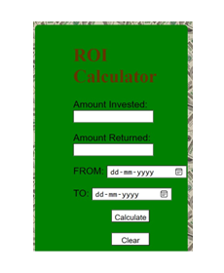

**CONCLUSION**

* Making a website is really a dream for a computer science student. Also, making website is really fun for a developer.
* Similarly, for our team making a website has always been interesting and fun.
* Though, we made a lot of mistakes while doing our project, we have learnt of lot about HTML and CSS.
* We learnt most important things that is teamwork which will be beneficial for our future, as we might be handling bigger projects in our future studies.
* We learnt the following:

1. Introduction to HTML
2. More to HTML
3. Forms
4. Introduction to CSS
5. Styling with CSS
6. Flex
7. More on styling
8. Responsive Design

***At the end, making a website is really good experience for a full stack developer .***

**REFERENCE**

W3School:-   [HTML Tutorial (w3schools.com)](https://www.w3schools.com/html/)

Render Forest:- [All your design tools in one place | Renderforest](https://www.renderforest.com/#Videos)

Canva:-  [Canva: Visual Suite for Everyone](https://www.canva.com/)

